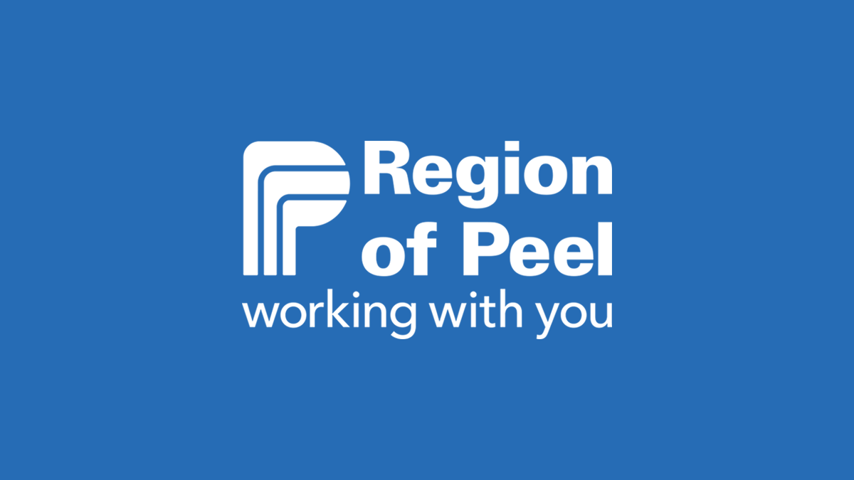

Program Support Analyst Strategic Sourcing & Vendor Relationship Management
Contract Full Time- 24 month duration
Corporate Services- IT Solutions

Salary range: $71,690-89,613
*Please note: The salary cannot exceed this range.

We have an exciting opportunity to join our IT Solutions team as a Program Support Analyst. This position will focus on the delivery of specialized guidance and advice on the development and implementation of programs that support the Region’s continuous improvement initiatives. These initiatives could include enterprise-wide technology products and services acquisition and vendor relationship.

You will provide professional support in the areas of project management, communications and change management in the development and design of programs for enterprise-wide technology products and services acquisition and vendor relationship.

This work will involve gathering information on trends, issues, gaps and statistics for inclusion in the development of divisional planning. You will prepare detailed documentation, conduct research and analysis and the scheduling of tasks to meet the divisional priorities.

How you work will be measured…
You will be responsible for developing process improvement activities, participating in implementation, and collection and assessment of sectional performance measurements. You will assist in the development and monitoring of performance metrics and analyze and interprets relevant measures as they relate to vendor relations, performance and Division service delivery.
Utilizing your expertise, you will assist with the development and delivery of the Vendor Management program and collecting and updating content for the Vendor Management program.
You will support the division with collecting and compiling data, information, and reports for various divisional initiatives. Lastly, perform continues investigation and research to support post-implementation of the Division’s key improvement initiatives and strategies.
Administrative:
- Collects, investigates and circulates standard management reporting using input from multiple team members in order to provide consistent reporting across the Division
- Develops communication materials for project and program roll-outs
- Undertake significant communications requiring negotiating and facilitate discussions with sections to identify service needs, client satisfaction levels and obtain information on service model options and assist staff with change
- Supports the project management efforts for the Division/section including: creating and maintaining templates, coordinating project review meetings, maintaining status of all projects and initiatives, assisting with the scheduling of project resources in a matrixed environment, completing research activities and preparing recommendations for business cases or projects
What we require…
- University or college graduate in Business Administration, Supply Chain Management or related discipline
- A minimum 3 years experience or an equivalent combination of education and experience
- Demonstrated vendor management & vendor relationship
- Excellent computer knowledge in Microsoft applications
- Significant research, analytical and practical problem solving abilities
Nice to have but not required…
- Proficient knowledge of principles and practice of public procurement will be an asset
- Municipal Experience
In this role you will have the ability to work remotely and attend on-site when required based on operational requirements at the 10 Peel Centre Drive, Brampton worksite. The frequency of on-site activities may vary on a weekly basis and based on operational requirements. Your remote work location must be located within the province of Ontario.

Hours of Work: 35 hours per week
The Region of Peel offers job based flexible hours of work that allows employees to manage personal and professional responsibilities while at the same time ensures business operational needs and customer service expectations are achieved.
Interview: Our recruitment process will be completed with video conference technology.

If this opportunity matches your qualifications and experience, please apply on-line at www.peelregion.ca/careers

As part of the Region’s ongoing commitment to health and safety, there are enhanced Covid-19 specific safety protocols and/or personal protective equipment requirements (e.g. masks, eye protection, etc.) in place to help protect health and safety. The additional requirements are determined based on the nature of the work being carried out.

New employees who commence employment on or after October 1, 2021 are required to be fully vaccinated against COVID-19 as a condition of employment. Being fully vaccinated is determined as the status of having received the full series of approved vaccines (both doses of a two dose vaccine series, one dose of a single dose vaccine series) and any additional doses required and approved by Health Canada and having satisfied the full post vaccination period required to ensure vaccination efficacy. The Region of Peel reserves the right to request proof of vaccination at any time. Acceptable proof includes an Ontario Ministry of Health COVID-19 vaccine receipt which you can obtain through the Provincial portal https://covid19.ontariohealth.ca/, or other government-issued vaccine passport or certification.

The requirement to be fully vaccinated is subject to the Ontario Human Rights Code. If you are not fully vaccinated, a documented medical reason provided by a physician or registered nurse and time period for the medical reason may be accepted.

